|  |
| --- |
| ***Sea Map Guide*** |



**Sea Map Guide**

**How to use & FAQs**

**Revision History**

|  |  |  |  |
| --- | --- | --- | --- |
| Version | Description of Change | Author | Date |
| *1.0* | *Initial Draft* | *Azharuddin Khan* | *6/11/2018* |
| *1.01* | *Updated Color Codes* | *Azharuddin Khan* | *6/13/2018* |
|  |  |  |  |
|  |  |  |  |

Contents

I. Your Top 3 questions answered: 4

II. Color Codes 8

III. Mouse Hover 8

IV. Vessel Information 9

V. Cargo Data 10

VI. Schedule, AIS and Vessel Reports 10

**Seamap link:** <http://jaxvycsdmzprd/Softship.SeaMap/#!/home>

# Your Top 3 questions answered:



1. **What is the ETA of the Vessel at the Port?**

Click on the vessel you are interested in. A Pop window like below will show.

The vessel ETA at next port is shown under Next Port Section

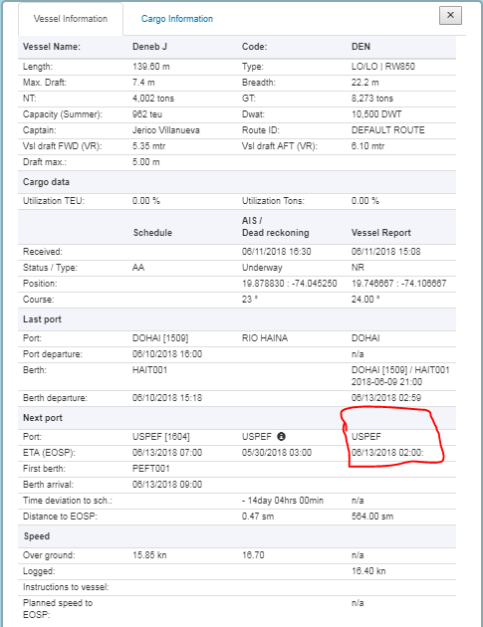



1. **How do I find if it is late, early?**

There are two ways to find if a vessel is late or early. One is the color on the vessel Name Box. Green shows vessel is ahead of planned schedule. The other is the Time deviation to schedule field.





1. **How can I tell information on the map is accurate or updated?**

There are two fields to check when the information was updated in SeaMap. For AIS data look under AIS Received and for Vessel Reports under the field Vessel Report Received

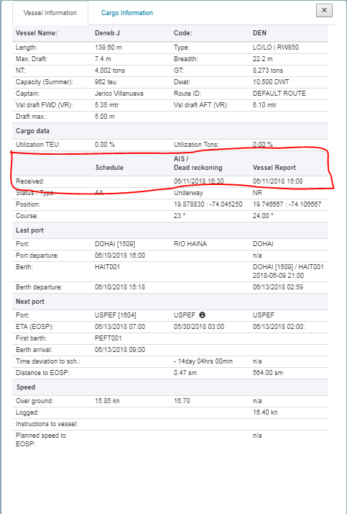

# Color Codes

|  |  |  |
| --- | --- | --- |
| Color | Status | Prerequisites / Further Information |
| White | Underway | Schedule destination does not match AIS destination |
| Red | Underway (delayed) | Schedule destination matched AIS destination and Time of AIS arrival is later then schedule arrival |
| Green | Underway (in time) | Schedule destination matches AIS destination and Time of AIS arrival is equal or earlier than schedule Arrival |
| Grey | Moored |  |
| Blue | At anchor |  |

# Mouse Hover

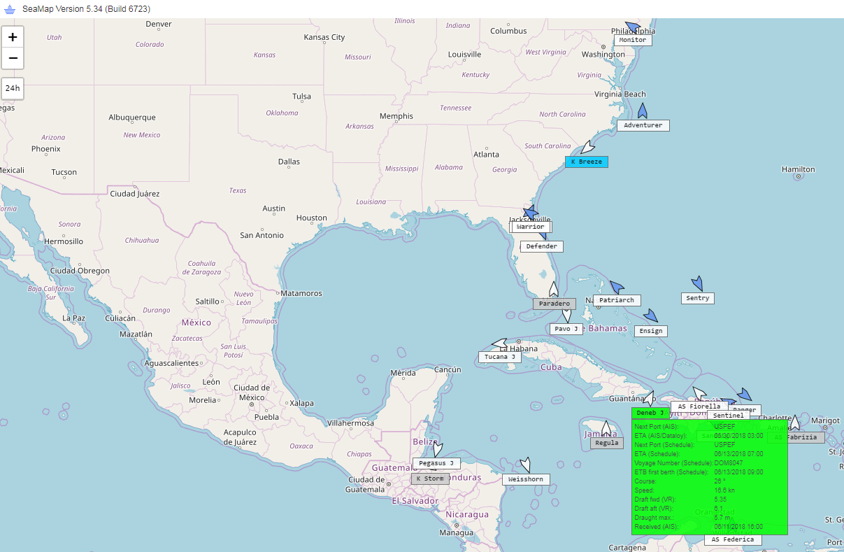

* Vessel Arrow icon: shows which service vessel is part of.
* Next Port (AIS): is next port based on Marine Traffic AIS Satellite data
* ETA (AIS/Dataloy): is Estimated time of arrival at next port based on Marine Traffic AIS Satellite data
* Next Port (Schedule): is next port based on Planned Schedule
* ETA (Schedule): is the estimated time of arrival based on Planned Schedule
* **Voyage Number: shows the current Voyage number of the vessel**
* ETB: is estimated time of berthing (docking) based on Planned Schedule
* Course: is updated from Marine Traffic AIS Satellite data
* Speed: is updated from Marine Traffic AIS Satellite data
* Draft fwd (VR): is updated from the Last Departure Report of the Vessel
* Draft aft (VR): is updated from the Last Departure Report of the Vessel
* Draught Max: is updated from Marine Traffic AIS Satellite data
* Received(AIS): is the last AIS data received in UTC times
* Green Box shows vessel is ahead of Planned schedule
* Red Box shows vessel is behind planned schedule
* Vessel Arrows in Blue represent vessels/barges not currently live in Voyces.

Note: all times are in in UTC. AIS data is provide by MarineTraffic which provides real-time satellite information on Vessel Position and tracking.

# Vessel Information

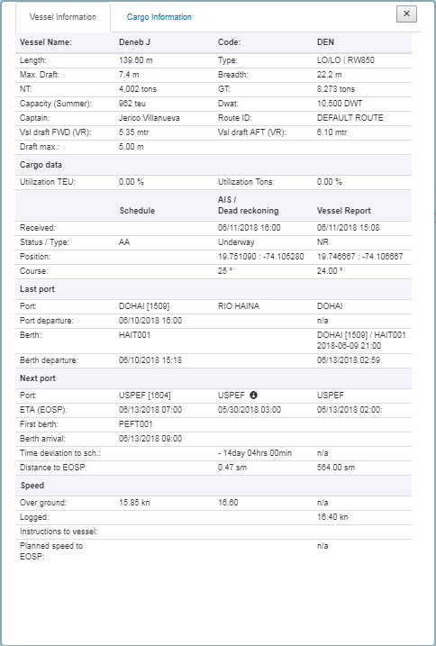

* This section’s information comes from Vessel Master data
* The Captain’s name, Vsl draft FWD and AFT are updated from Vessel Reports sent by Captain.

# Cargo Data



* No cargo Information in this phase

# Schedule, AIS and Vessel Reports

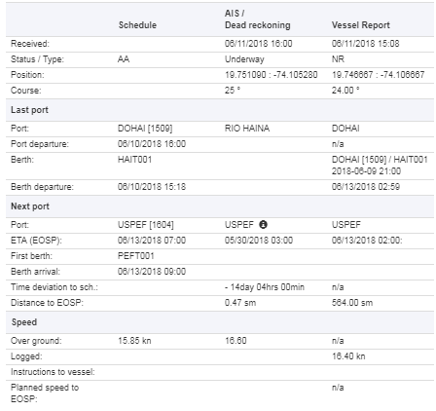

* **Schedule (Planned Schedule) :**
  + Status/ Type: This section shows what the status of planned schedule is.
    - There are three status of a Schedule (i)PP (ii) AP & (iii) AA
      * PP status show the schedule is still in planned status and no actual values exist.
      * AP means the arrival part of the port call is complete and the vessel has sent Arrival Report
      * AA means the departure part of the port call is complete and the vessel has sent the Departure Report
* **AIS/Dead reckoning (Shows the latest AIS Satellite data)**
  + Received: shows when Last AIS data was last received in UTC times
  + Status/Type: shows status of Vessel voyage
  + Position: shows vessel coordinates
  + Course: shows vessel course
* **Vessel Report (Reports sent by Captain)**
  + Received: shows when Last Vessel Report was received in UTC times
  + Status/Type: shows the last report type that was received
    - AR (Arrival Report)
    - DR (Departure Report)
    - NR (Position/ETA Report) In this example the vessel has already departed DOHAI and sent NR Reports.
  + Position: Coordinates reported by Captain
  + Course: Course Reported by Captain

1. **Last Port**



* Schedule
  + Port: shows the last port on the Planned Schedule
  + Port Departure: shows the planned departure time (BOSP) based on Schedule for last port
  + Berth: shows the last berth on the Planned Schedule
  + Berth Departure: shows the planned departure time (Unberthing) based on Schedule for last berth
* AIS/ Dead reckoning
  + Port: shows the last port based on AIS data
* Vessel Reports
  + Port: shows the last port based on Vessel Report
  + Port Departure: shows the actual departure time (BOSP)
  + Berth: shows the last berth based on Vessel Report
  + Berth Departure: shows the actual departure time (Unberthing)

1. **Next Port**



* Schedule
  + Port: shows the next port on the Planned Schedule
  + ETA (EOSP): shows the planned estimated time of arrival (End of sea passage)
  + First berth: shows the next berth on the planned schedule
  + Berth Arrival: shows the planned estimated time of arrival at berth
  + Time deviation to schedule: N/A
  + Distance to EOSP: N/A
* AIS/Dead reckoning
  + Port: shows the next port on based on AIS data
  + ETA (EOSP): shows the AIS estimated time of arrival
  + First berth: N/A
  + Berth Arrival: N/A
  + Time deviation to schedule: difference between AIS and Planned Schedule ETA
  + Distance to EOSP: shows distance to end of sea passage (arrival) based on AIS data
* Vessel Report
  + Port: shows the next port based on Captain’s Vessel Report
  + ETA (EOSP): shows the ETA estimated time of arrival (End of sea passage)
  + First berth: shows the next berth
  + Berth Arrival: shows the estimated time of arrival at berth
  + Time deviation to schedule: difference between Vessel ETA and Planned Schedule ETA
  + Distance to EOSP: shows distance to end of sea passage (arrival) based on Vessel Reports

1. **Speed**



* Schedule
  + Over ground: planned speed
* AIS/Dead reckoning
  + Over ground: AIS data speed of vessel
* Vessel Report
  + Logged: Last actual speed logged by Captain in the latest Daily Position Report